《桌邊談》二〇一九年六月號的文章主題鮮明——認信的教會。歷史性的正統基督教在信仰告白的幫助下宣講並傳承了從一開始就交付給使徒的信仰。信仰告白是駁斥異端的文件，同時信仰告白也定義了我們所相信的聖經教導。近年來，教會使用信仰告白的情況很不理想，一些教會完全忽視信仰告白，另一些則簡化了信仰告白，結果就是它們不足以維持正統的信仰和實踐。這導致了一代自稱基督徒的人不清楚教會的信仰，並且在很大程度上無法將信仰完整地傳給在他們之後要來領導上帝百姓的人。

本期《桌邊談》將幫助教會重建認信主義，展示信仰告白的必要性，以及信仰告白在教會生活各個層面的價值。

https://zh.ligonier.org/tc/blog/series/the-confessing-church/
https://tabletalkmagazine.com/issue/2021/06/the-confessing-church/

Burk Parsons柏克‧帕森博士是《桌邊談》雜誌的編輯，並且是佛羅里達州桑福德聖安德烈堂的資深牧師。他是《上帝的保證：活在上帝整全的恩典中》（Assured by God: Living in the Fullness of God’s Grace）的編輯。他的推特名稱是@BurkParsons。

真誠地認信 2022年08月19日
大約十年前，我受邀寫一本名為《為何需要信條》的小書。回答這個問題的目的是幫助基督徒了解信條和認信的重要性以及必要性，尤其是那些沒有認信背景的基督徒。我自己出身於非認信背景的教會，直到1997年讀到西敏準則時，我才明白信條和認信的益處。因此，直到如今我都由衷地支持使用信條和信仰告白。本期《桌邊談》的主要內容是呼籲教會回歸使用歷史信條和信仰告白，並忠心地肯定其益處。我們要做的不僅僅是口頭宣信，這在今天的教會中越來越普遍。
根據《為何需要信條》這本小書的內容，我提出十個維護認信的論點，用以制定教會信條和信仰告白，並了解其目的和實用性。信條和信仰告白的目的在於：（1）藉著相信、承認和宣講根據神在祂自我啟示的話語中得出的教義，以此榮耀神，以祂為樂，直到永遠；（2）認信獨一的全能真神，祂向我們啟示了祂自己，祂的屬性、祂的律法和祂的救贖工作，這表明祂是我們唯一的主，使我們可以全心全意全力地愛祂；（3）保守聖經不變、純正的教義，反對教會外的假教師和異端，以及教會內錯誤的聖經觀念；（4）分辨真理與錯誤的教義，分辨完整的真理與部分的真理；（5）作為聖潔的、大公性的和使徒性的教會，相信、承認和宣講純正的聖道，並正確地施行聖禮—洗禮和聖餐，也包括持續實施教會懲戒。在任何時代中都要保持堅忍，直等到基督再來；（6）堅持聖道是神所默示且無誤的，其權力範圍包含生活的各方各面。這個有關聖道的教義是我們信仰和生活唯一無誤的權威；（7）維護基督徒的良心自由，不受聖經外的律法、傳統和迷性的綑綁；（8）根據教會的教義標準確認被選為教會職員的人，裝備、查驗和證明他們；（9）保守教會的純潔，進而保持教會的平安與合一，作為基督顯明於世界的見證；（10）完成大使命，確認和宣講唯一真實的耶穌基督的福音，使萬民作祂的門徒，給他們施洗使他們歸入聖父、聖子和聖靈的名，並教導他們遵守我們主耶穌基督所吩咐的一切。

https://zh.ligonier.org/tc/articles/genuinely-confessional/

Genuinely Confessional
Dr. Burk Parsons (@BurkParsons) is senior pastor of Saint Andrew’s Chapel in Sanford, Fla., chief publishing officer for Ligonier Ministries, editor of Tabletalk magazine, and a Ligonier Ministries teaching fellow. He is author of Why Do We Have Creeds?

About ten years ago, I was asked to write a little book called Why Do We Have Creeds? In answering that question, my aim was to help Christians, particularly those Christians from non-confessional backgrounds, to understand the importance and necessity of creeds and confessions. I myself come from a non-confessional background, and I had never understood how helpful creeds and confessions were until I read the Westminster Standards in 1997, which I heartily affirm to this day. In this issue of Tabletalk, our hope is to call the church to return to her historic creeds and confessions, and to affirm them faithfully—not with mere lip-service, which is becoming increasingly commonplace in the church today.
I offer here a ten-point apologetic of sorts—based on the content from Why Do We Have Creeds?—for the formulation, usefulness, and purpose of the church’s creeds and confessions. The purposes of creeds and confessions are (1) to glorify God and to enjoy Him forever by believing, confessing, and proclaiming our doctrine in accordance with what He has revealed in His Word; (2) to affirm the one true God almighty who has revealed Himself to us and whose attributes, laws, and redemptive work point us to Him as our only Lord so that we might love Him with our entire being; (3) to guard the unchanging, sound doctrine of Scripture against false teachers and heretics outside the church and against false notions of Scripture from within the church; (4) to discern truth from doctrinal error and to discern truth from half-truth; (5) to remain steadfast through the ages until Christ’s return as one, holy, catholic, and Apostolic church that believes, confesses, and proclaims the pure Word of God and that rightly administers the sacraments of baptism and the Lord’s Supper, including the consistent exercise of church discipline; (6) to uphold the life-encompassing doctrine of the inspired and inerrant Word of God as our sole infallible authority for faith and life; (7) to maintain freedom for Christians from extrabiblical laws, traditions, and superstitions that bind people’s consciences; (8) to confirm men according to the church’s doctrinal standard who have been elected to serve as officers of the church and to equip, examine, and prove those men; (9) to preserve the purity and thereby the peace and unity of the church visible as the outward witness of Christ to the world; and (10) to fulfill the Great Commission in our affirmation and proclamation of the one true gospel of Jesus Christ by making disciples, baptizing them in the name of the Father, the Son, and the Holy Spirit and teaching them to observe all that our Lord Jesus Christ commands.

https://tabletalkmagazine.com/article/2021/06/genuinely-confessional/

Burk Parsons柏克‧帕森博士是《桌邊談》雜誌的編輯，並且是佛羅里達州桑福德聖安德烈堂的資深牧師。他是《上帝的保證：活在上帝整全的恩典中》（Assured by God: Living in the Fullness of God’s Grace）的編輯。他的推特名稱是@BurkParsons。

我們為什麼要認信？ 2022年08月24日
日常生活中，我們每天都能聽到別人說「我相信」。無論處境是什麼，我們都可以用這簡單的三個字來表達對幾乎所有事情的想法。當我們試圖告訴別人自己的想法，或者表達內心最深處的情感時，我們就常常會說「我相信」。上帝以祂的智慧創造了我們，使我們不僅具備相信的能力，還擁有探索、研究和表達信仰的意願，而且永不滿足（箴二；彼前一）。在我們的靈魂深處有一種神賜的飢餓感，這種飢餓感使我們迫切地想要研究上帝向我們啟示的所有基要的真理（申四；太二十二）。
單單只是相信某事並不會為我們帶來任何實際上的幫助。在最基本的層面上，相信某事只會讓我們產生一種強烈的感覺，感受到自己並不孤單，並且感受到有一個超越性的存在。每個人都具備相信的能力，實際上每個人也都相信著某事（徒十七）。懷疑論者可能會聲稱自己「什麼都不相信」，然而根據他的說法，他相信的其實就是「什麼都不」。然而，即使是堅定的懷疑論者也知道，什麼都完全不相信也是不可能的。如果有人聲稱自己什麼都不相信，那麼真相就是，他所相信的一切都是按照他的方式、以他自己為中心的信念，以他自己作為來源和對象、作為開始和結束的。與主流看法不同的是，對一切都抱持開放的態度並不是一件好事，無論得到的資訊有多荒謬，因為他沒有判斷標準用以辨別這些資訊的真假對錯，也無法區分完全的真理和半真半假的說法（箴一22, 32），這樣的人就會不加分辨地將資訊全部裝進腦袋。開放的心實際上就只是一個充斥著感受和偏好的公共空間。
因為信仰能改變人心、改變生命，這就需要上帝既是信仰的來源又是信仰的對象（詩六十八26；林前二5）。作為基督徒，我們都是在耶穌基督裡新造的人，聖靈滿有恩典地擊碎我們堅硬的石心，賜給我們屬靈的、柔軟的新心，使我們現在就能夠相信、宣認和傳講榮耀且永恆的真理，也就是上帝的聖道（路二十四45）。對於上帝所啟示的所有事物，我們都要保持開放的態度；這樣，我們就必然要對與之相反的事物完全地、殷勤地關閉心門。身為基督徒，我們相信、宣認和傳講的就單單只有上帝的真理。這就是為什麼我們要有信經和信條，好叫我們以堅定不移的決心堅守那曾經交付給聖徒的信仰，使我們和我們的兒女最終都會相信、宣認並傳講榮耀的上帝的那不變的真理，因為上帝是一切我們所信之事的源頭，因此，祂的啟示是信仰和生活的唯一準則。

人人都有信條
每個人都有自己的信條，因為每個人都有相信的事，更重要的是，每個人都相信上帝。即使自稱是無神論者的人也相信有一位上帝，因為上帝在創造中啟示了祂自己，並且基於所有人都是按照神的形象所造的這個事實，我們無可推諉（羅一18-20）。所謂的無神論者也都深知有神，但他們恨惡上帝，假裝上帝不存在會讓他們比較心安。但我們都知道，即使是惡魔也相信上帝存在，並且恐懼戰兢（可五7；雅二19）。
如果每個人都相信上帝，那麼問題就來了：我們相信關於上帝的什麼？如何回答這個問題實際上就是在認信或宣告我們的信條，人人都有詳細說明自己信仰的信條或信經，無論是正式的還是非正式的，書面的還是口頭的。有些人遵守正式的、書面的信條，另一些人則認信非正式的、不成文的信條，然而非正式的信條很容易就會改變，或許也確實常常在改變。
人生來就是教義性的，從出生的那一刻起，我們就開始建立信仰的概念。從概念的形成到信仰的實際表達，我們自然而然地就會傾向於以口頭或是書面的形式制定成文的信條來表達信仰，信條也能將我們和信奉同樣的真理的人聯合在一起。按照上帝的設計，人都是會制定信條的，不管是墮落前還是墮落後的人，即使未來在永恆的新天新地也是一樣。所以真正的問題不在於我們是否需要信條，而在於我們所信的信條內容是什麼？我們信仰的本質是什麼？我們信條的權柄、作用、基礎和目的是什麼？

每當有人在思考上帝的啟示的時候，就是他開始制定信條的時候。

有些人認為信條和信仰告白不符合唯獨聖經這個教義。既然上帝將聖經賜給我們作為信仰和生活唯一無誤的準則，那麼自然就可以得出結論說，聖經是完全充分的、決定性的且沒有爭議的。毫無疑問地，我們得救只需要上帝的話語，因為上帝自己就是這樣教導我們的（約十七17；提後三16；彼後三16）。既然這樣，為什麼還需要《使徒信經》或《尼西亞信經》這樣的歷史性的信條呢？同樣的，為什麼還需要十六、十七世紀時候的《西敏信條》和《海德堡要理問答》這樣的改革宗的信條和要理問答呢？如果只有聖經是「於教訓、督責、使人歸正、教導人學義…是有益的」，叫我們能妥善地「預備行各樣的善事」（提後三16-17），那我們為什麼還需要其他呢？如果全能的主上帝定意我們擁有超過六十六卷聖經的內容，祂不也能很簡單地就將其他的信仰文本賜給我們嗎？基督徒生活和教會生活真的需要信條和信仰告白嗎？
在談到信條和信仰告白時，這些是每個基督徒必然會遇到、無法迴避的問題。我們也很容易可以看到，不僅是在談及信條時需要思考這些問題，在談及教義的性質和研究教義的目的時也需要思考這些問題。更重要的是，這些問題會自然而然地延伸到聖經研習的任何一個領域、甚至是所有的領域：所有的聖經註釋、所有的系統神學、所有的講道，所有有關聖經中任何內容的討論和爭論… 每當有人在思考上帝的啟示的時候，就是他開始制定信條的時候。當我們教孩子唱著像「耶穌愛我我知道，因為聖經告訴我」這樣的兒歌的時候，我們就是在形成信仰宣告，我們在宣告耶穌和祂的愛、愛的對象、愛的確據，以及聖經權柄的本質。
有些人可能仍然會說：「我唯一的信條就是信基督」。只要我們開始詢問「誰是基督」的時候，人們就會開始表達他對基督的認信，這種認信可能是對的，也可能是錯的；可能合乎聖經，也可能不符合聖經。如果我們所信的有關基督的位格和祂的工作的內容不符合聖經，這樣的信仰就會定我們的罪。因為如果只有聖經中的基督是將我們聯合起來的那一位，我們就必須確信唯一的、真正的、合乎聖經的基督，這樣才能得到聖經所說的真正的救恩與真正的合一。因此，「我唯一的信條就是信基督」這種說法是對的，每個基督徒的目標都是相信基督，也就是相信、宣認和傳講聖經所啟示的，由基督親自授權、親自實現、親自辯護和宣講的信條以及教義內容。如果我們是唯獨相信基督的真正的基督徒，我們就必然會認信基本的救恩教義，承認基督是我們的主和救主。那麼就只剩下一個問題了，教義到底是可靠的還是錯誤的。

信條和信仰告白就像是信仰先賢留給我們的地圖
將信條和信仰告白看作是地圖或指南，以此來引導我們學習上帝的話語，這對我們是大有幫助的。有人會爭辯說旅行時不一定真的需要地圖，但我們都知道，如果想在特定的時間、走特定的路線到達特定的目的地，地圖就會給我們帶來很大的幫助。要去不熟悉的地方，使用地圖就更有必要的了；走一條經常走的路不需要查看地圖，因為我們已經將路線記在了腦海中。但是，如果不是定期前往某個地方，我們還是有可能會因為沒想清楚或者記性不好而迷路或是繞遠路。聖經是一個由山川河流組成的美麗而廣闊的世界，上帝呼召我們去定位每一座山川、每一條小徑，去攀登高峰、在小徑中漫步，我們當仰望我們的先輩，像他們那樣世代相傳、忠誠地奔走天路。
儘管如此，還是會有人輕易地升級對信條和信仰告白有效性的指控，他們聲稱信仰的先輩雖然衷心，卻也是罪人，因此他們沒有資格為教會制定這樣的指導方針。對於這種指控有兩種回應的方式：第一，即使在人們陷入罪的泥沼之後，上帝還是持續地呼召、賜恩和裝備那些悔改得救的罪人，使他們能服事上帝和祂所呼召出來的百姓，也就是教會，好叫上帝的百姓最終能相信、宣認和傳講真理。第二，既然悔改得救的罪人也會自然地傾向於制定信條，我們就必須明白，是我們自己的罪導致教會內部的分歧、爭論和分裂。然而，這些正是上帝在祂的話語中明令禁止的。因此，雖然我們可以總結說，我們自然地傾向於相信不同的信仰是因為罪的緣故，但同樣也是由於罪的緣故，我們應當努力制定成文的信條，以此來確定聖經的教義。儘管信徒在屬靈的意義上是已經重生的，然而罪還是對我們的理性產生了影響，因此，在我們研習聖經的時候，有時候我們並不像自己所想的那樣思路清晰、思考仔細。然而，上帝在祂的恩典中將聖靈賜給我們，在祂的智慧中將牧師和教師賜給我們，一直到基督再來成全祂的國度。聖靈光照我們明白祂的話語，透過祂裝備並使用的僕人在佈道、查經、撰寫注釋書和其他神學相關的書籍，以及編著信經這些方面，研究、解釋和教導上帝的真理，並在話語的真道中帶領我們。 因此，信經、信條和講道的作用是類似的，是成文的、書面寫成的說明，旨在為我們提供對聖經教義的清晰的總結。
罪不僅混亂我們的思想，也會混淆我們的記憶。對於從聖經中學習到的內容我們常常記得不全，學得也不夠快，這就是為什麼上帝自己也會把祂的話語總結成信條的形式，並將它們賜給我們（申六4；提前三16 ）。正如聖經中信條式的陳述那樣簡潔明瞭，教會歷史中制定出來的信條為我們提供的也是簡明且系統性的聖經教義，有助於我們更好地學習和記得我們的主在祂的話語中啟示給我們的教義。
如果沒有罪的話，幾乎所有的事物都會不一樣，我們就不會需要任何的信經或信條；如果我們不是罪人的話，我們就都能按照上帝的心意來閱讀和相信祂的話；我們不會在任何一點上對聖經心存異議；教會也不會有紛爭或分裂； 不會有假教師，不會有異端思想，也不會需要教會懲戒。獨一的、聖潔的、大公性的、使徒性的教會將會在所有的事情上完全地合一，這將會在新天新地中實現。遺憾的是，我們是罪人，有著被玷污的心和墮落的思想，結果就是我們常常低估了罪對人的影響，這不僅將我們置於上帝的對立面，也使我們彼此之間很難互相認同。我們絕對不能低估罪的後果。相反，我們必須重視人的敗壞，重視罪是如何影響我們所想的、所說的、所行的，以及這一切背後的動機。正是因為不止是我們中的某一個人是罪人，而是我們每一個都是罪人，因此我們才需要信經和信條。

信條將我們聯合起來
與普世觀點不同的是，制定信經和信條不是為了分化我們，而是為了聯合我們這些在基要信念上對獨一的真信仰彼此認同的人。教義不會導致分化，信經和信條也不會，罪才是帶來分裂的罪魁禍首，而教義卻能使我們聯合。通過我們與基督的聯合，透過聖靈的力量，我們確定下來的聖經教義是唯一可能將我們這些人聯合起來的事物，就是一群由我們所認信的權能的上帝所拯救的、由悔改的罪人所組成的教會。

https://zh.ligonier.org/tc/tabletalk/the-confessing-church/why-were-confessional/

Why We’re Confessional
Dr. Burk Parsons (@BurkParsons) is senior pastor of Saint Andrew’s Chapel in Sanford, Fla., chief publishing officer for Ligonier Ministries, editor of Tabletalk magazine, and a Ligonier Ministries teaching fellow. He is author of Why Do We Have Creeds?

“I believe.” We hear these words every day of our lives. Whatever the context, we use these two simple words to express our thoughts about nearly everything. When we want to tell others what we are thinking or want to reveal the innermost affections of our hearts, we will often say, “I believe.” In His wisdom, God created us not only with the capacity to believe but also with an insatiable desire to explore, examine, and express our beliefs (Prov. 2; 1 Peter 1). We possess a God-given hunger deep within our souls that causes us to examine fundamental truths about everything God has revealed to us (Deut. 4; Matt. 22).
The mere fact that we believe in something doesn’t actually do anything for us. At the most basic level, a belief in something only provides us with the overwhelming sense that we’re not alone and that something exists beyond us. Everyone has a capacity to believe in something, and in fact everyone actually does believe something (Acts 17). Although the cynical skeptic might say, “I believe in nothing,” the simple point is that he does believe in something, and according to him that something is “nothing.” But even the convinced skeptic knows that it is impossible to believe in absolutely nothing. If someone claims to believe in nothing, the truth of the matter is that he actually believes in everything that begins and ends with himself as the source and object of his self-fashioned, self-centered faith. He has an open mind about everything, which, contrary to popular opinion, is not a good thing. Someone who has an open mind about everything will uncritically allow any and all data, no matter how absurd, to enter his mind because he has no filters—no criteria—to discern right from wrong, truth from falsehood, and even truth from half-truth (Prov. 1:22, 32). The open mind of everything is an undiscerning open space, filled only with perceptions and inclinations.
For belief to have heart-changing and life-changing significance, it requires God as both its source and object (Ps. 68:26; 1 Cor. 2:5). As Christians, we are new creatures in Jesus Christ, and the Holy Spirit has graciously ripped out our hard hearts of stone and given us new, spiritually pliable hearts so that we are now able to believe, confess, and proclaim the glorious and eternal truths of God’s sacred Word (Luke 24:45). We are to be open-minded to anything and everything that God has revealed to us, and by necessity we are to be completely, albeit graciously, closed-minded to anything that contradicts what He has revealed. As Christians, we believe, confess, and proclaim God’s truth and nothing but God’s truth. This is why we have creeds and confessions, so that with unwavering resolve we might stand firm in the faith once delivered to the saints—to the end that we and our children would believe, confess, and proclaim God’s unchanging truth for His glory, for He is the source of everything we believe and, thus, His revelation is our creedal standard for all of faith and life.

EVERYONE HAS A CREED
We have creeds because everyone believes in something, and even more to the point, everyone believes in God. Even self-proclaimed atheists believe there is a God, by virtue of God’s revelation about Himself in creation and the fact that all people are created in His image, and thus we are left without any excuse whatsoever (Rom. 1:18–20). So-called atheists know full well there’s a God; they just hate God and find it easier for their consciences simply to pretend He does not exist. But, as we know, even demons believe God exists and rightly tremble (Mark 5:7; James 2:19).
If everyone believes in God, the question then follows: What do we believe about God? To answer the question is to confess, or declare, our creed. Whether formal or informal, written or verbal, in one way or another we all have a creed that details our beliefs. Some of us have a formal, written creed we adhere to, while others have an informal, unwritten creed that can easily change and perhaps often does change.
We are creedal by our very nature and begin to form concepts of belief from the moment we are born. As we move from the formation of concepts to actual statements of belief, we are naturally inclined toward verbal and even written creedal formulations that express our beliefs and unite us with other people around truths to which we all agree to adhere. By God’s design, the entire human race is creedal—before the fall and after the fall—and will be throughout eternity in the new heavens and new earth. So the real question is not whether we have creeds. Rather, the questions are, What do we believe in our creeds? What is the nature of our belief? What are the authority, usefulness, foundation, and purpose of our creeds?

Anytime someone considers for a moment what God has revealed, he has begun to formulate a creed.

Some find creeds and confessions incompatible with the doctrine of sola Scriptura. Since God saw fit to provide us with Scripture as our only infallible guide for faith and life, it necessarily follows that Scripture is completely sufficient to serve as the final, incontrovertible judge and standard of our beliefs. Right? Without a doubt—all we need for salvation is God’s Word. That’s precisely what God Himself teaches us (John 17:17; 2 Tim. 3:16; 2 Peter 3:16). So, then, what about the historic creeds of our faith, such as the Apostles’ Creed or the Nicene Creed? What about all the Reformed confessions and catechisms of the sixteenth and seventeenth centuries, such as the Westminster Confession of Faith and the Heidelberg Catechism? If Scripture alone is profitable for teaching, reproof, correction, and training in righteousness to the end that we would be competent and equipped for every good work (2 Tim. 3:16–17), then why do we need anything else? If the Lord God Almighty wanted us to have anything beyond the sixty-six books of sacred Scripture, could He not have simply provided it to us? Are creeds and confessions really needed in the life of the Christian and in the life of the church?
These are necessary and inescapable questions that every Christian must consider when it comes to creeds and confessions. And we can easily see how such questions extend not only to creeds but to the nature and purpose of the study of doctrine itself. What’s more, such questions extend naturally to any and all study of Scripture—all commentaries, all systematic theologies, all sermons, and all discussions and disputes about anything in the Bible. Anytime someone considers for a moment what God has revealed, he has begun to formulate a creed. Whenever we sing simple songs to our children, such as “Jesus loves me, this I know, for the Bible tells me so,” we have formulated a creedal statement about Jesus, His love, the object of His love, our assurance of His love, and the nature of biblical authority.
Still, some might say, “My only creed is Christ.” But as soon as we ask the question, “Who is Christ?” we will hear someone’s expression of his creedal understanding about Christ, which will be either right or wrong, biblical or unbiblical. And an unbiblical belief about the person and work of Christ will result in our condemnation. For if it is the Christ of the Bible who unites us, we must affirm the one, true biblical Christ to have true biblical salvation and true biblical unity. Thus, it would be quite appropriate to say, “My only creed is the creed of Christ.” This is the aim of every Christian—namely, to believe, confess, and proclaim the very creed and doctrine revealed in Scripture that Christ Himself authored, fulfills, defends, and proclaims. If we are genuine Christians who trust Christ alone, it is impossible for us not to affirm the elementary saving doctrine of Christ our Lord and Savior; the only question is whether the entirety of our doctrine is sound doctrine or false doctrine.

CREEDS AND CONFESSIONS ARE LIKE MAPS FROM OUR FOREFATHERS
It may be helpful to think of creeds and confessions as maps, or guides, to help us navigate our way as we study God’s Word. While someone could argue that we don’t really need maps to travel, we all know how helpful maps are if we want to arrive at a particular destination by way of a particular route in a particular amount of time. We use maps whenever we need assistance getting to a particular destination that is not familiar to us, but we do not typically look at a map of a road we have traveled often because we have committed that route to memory. But unless we travel to a particular destination regularly, we can lose our way and wander off the most convenient route because our minds do not think as clearly or remember as fully as we would like. The Bible is a beautiful and vast world of mountains, rivers, and paths, and we are called to climb them, navigate them, and walk them as we look to, learn from, and lean our forefathers who have traveled them faithfully in generations past.
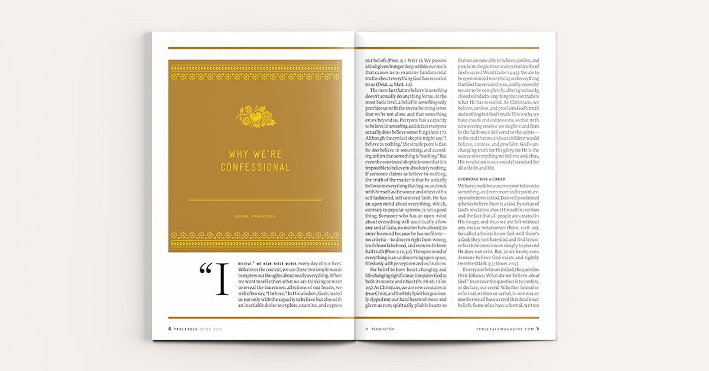
Still, someone could easily level the charge against the usefulness of creeds and confessions by pointing out that our forefathers, though faithful, were sinners and therefore disqualified from formulating such guides for the church. There is a twofold response to this charge. First, after our fall into sin, God has continued to call, gift, and equip redeemed and repentant sinners to serve Him and His called-out people, the church, to the end that God’s people would believe, confess, and proclaim His truth. Second, as redeemed and repentant sinners who are naturally inclined to formulate creeds, we must grasp that it is our sin itself that leads us to disagree, dispute, and divide within the church, which is precisely what God Himself commands against in His Word. So, while we can conclude that it is because of sin that we are naturally inclined toward differing beliefs, it is also because of sin that we should strive diligently to formulate a written creed that affirms the doctrines of Scripture. Even as spiritually regenerate believers, we suffer the noetic effects of sin and do not always think as clearly and as carefully as we should when we study Scripture. However, in His grace God has given us His Spirit, and in His wisdom He has given us pastors and teachers until Christ’s consummation of His kingdom. The Holy Spirit illumines His Word to us and leads in the truth of His Word as He enables and employs His servants to study, explain, and teach His truth in sermons, Bible study lessons, commentaries, books, and creeds. So creeds and confessions, similar to sermons, are written, formulated explanations meant to provide us with a clear summary of the doctrine of Scripture.
Not only does sin cloud our thinking; it clouds our memories. We do not always remember as fully and as quickly as we should from our study of Scripture, which is why God Himself has given us creedal summaries of His Word throughout His Word (e.g., Deut. 6:4; 1 Tim. 3:16). And just like the concise creedlike statements in Scripture, the church’s historic creeds provide us with a concise system of the doctrine of Scripture so that we might better and more easily learn and remember the doctrine our Lord has revealed to us in His Word.
Without sin, just about everything would be different, and we would not have any need whatsoever for creeds and confessions. If we were not sinners, we would all read and believe God’s Word exactly as God intended. We would not disagree about anything in Scripture. There would be no divisions in the church. There would be no false teachers, no heresy, and no need for church discipline. The one, holy, catholic (universal), and Apostolic church would completely agree on everything. And this will be the reality in the new heavens and new earth. But alas, we are sinners with depraved hearts and debauched minds as a result of the often-underestimated fall of man into sin, which put us at enmity not only with God but also, to a lesser degree, with one another. We must not underestimate the consequences of sin. Rather, we must have a high regard for the depravity of man and for the overwhelming effects of sin on all we think, say, and do and on the motives behind all we think, say, and do. Consequently, it’s precisely because each and every one of us is a sinner and because there is more than one of us that we need creeds and confessions.

CREEDS UNITE US
Contrary to popular opinion, we have creeds and confessions not to divide us but to unite us on the foundational beliefs of the one and only true faith. Doctrine doesn’t divide; nor do creeds and confessions. Sin is what divides us, and doctrine is what unites us. Through our union with Christ, and the power of the Holy Spirit, our affirmation of biblical doctrine is the only thing that can possibly unite a church made up of repentant sinners who are saved by our sovereign God whom we confess.

https://tabletalkmagazine.com/article/2021/06/why-were-confessional/

John R. Muether穆瑟是改革宗神學院奧蘭多分校（Reformed Theological Seminary in Orlando）圖書館員暨教會歷史學教授。他曾經著有、合著或編輯多本書籍，包括《尋求更美好的國家：美國長老會300年歷史》（Seeking a Better Country: 300 Years of American Presbyterianism.）。

歷史上認信的教會 2022年08月26日
舊約表明上帝的百姓從一開始就是個認信的群體，而且一直都是。聖經中「最根本的信經」是「示瑪」：「以色列啊，你要聽，耶和華我們的神是獨一的主。」（申六4）耶穌（可十二29）和保羅（林前八4-6）都曾引用過這一信經。在西奈山上，上帝親自啟示祂自己是一位「有憐憫有恩典的神，不輕易發怒，並有豐盛的慈愛和誠實」的神（出三十四6）。根據一些學者的判斷，這種表達方式對舊約的百姓來說也起到了類似信條的作用；在以色列的故事裡，從摩西五經（聖經開頭五卷書）到先知書，這種表達方式重復了好幾次，在詩篇中也用到了三次（詩八六15；一零三8；一四五8）。
同樣的，新約中也可以找到信經的聲明。提摩太前書第二章第5節和第三章16節就是兩個例子。對此，歷史學家雅羅斯拉夫·佩利肯（Jaroslav Pelikan）說：「說保羅在引用「或口頭或書面的，非常早期的基督教信仰告白，是很合理的」。其他學者也認為，保羅在教牧書信中的一些「可信的話」也源自早期教會的信條或儀文。
隨著古代教會持續地實踐，早期的信經摘要成為了「信仰準則」（rule of faith），這是從使徒那裡得到的教義摘要，並傳給了後代。早期基督教關於三位一體論和基督論的爭議促使教會磨練其對信仰的表述，教會定下信經，以表達其關於三位一體論和基督論的認信。信經能幫助教會教導，也能譴責偏離教義的看法（例如，尼西亞會議、君士坦丁堡會議和卡爾西頓會議）。
許多基督教傳統在這些古老的信條基礎上還添加了許多信仰告白。那麼信經（creeds）和信仰告白（confessional statements）之間有什麼區別呢？一般來說，信經寫於教會開始的前幾個世紀，通常是非常簡短的教義申明，聚焦於三位一體的屬性或聖子的道成肉身，並且普世教會都接受，因此被稱為「大公信條」（ecumenical creeds）。三個主要的大公信經是《使徒信經》、《尼西亞信經》和《亞他那修信經》。在這些信經的基礎上，十六和十七世紀的信條則表達了特定地區的改革宗信仰，例如法國信仰告白（the French Confession）或蘇格蘭信仰告白（the Scots Confession），用以應對外來的威脅（如重洗派的偏差或阿米念主義的挑戰），或是為改革宗信仰和生活的全面發展提供教義支持（如盟約神學和教會治理）。

當信條遇見分歧
制定信條是為了維護上帝百姓的合一，因為他們「同得寶貴信心」（彼後一1），但他們並非總是如此，有時候我們確實看到教會的分裂。西方教會在《尼西亞信條》中增加了「和子論」（filioque，認為「聖靈是由聖父和聖子而出的」的說法），這導致了1054年東西方基督教的分裂。
1529年的馬爾堡會議（Marburg Colloquy）試圖將新教的改革宗和路德宗聯合起來，雙方在15個教義要點中的14點上達成一致，唯獨在有關基督在聖餐中以何種形式臨在的這個議題上，馬丁·路德和烏利希·慈運理（Huldrych Zwingli）沒有達成一致。這使得新教的發展遇上了悲劇性的挫敗，梅晨（J. Gresham Machen）認為這個分歧是一場「災難」，但他補充道，如果路德把有關聖禮的分歧看作是「微不足道的事情，那將會是更大的災難，因為這種漠不關心的態度比教會當中所有的分歧都更加致命。」

早期的信條摘要就成為了「信仰準則」，這是從使徒那裡得到的教義摘要，並傳給了後代。

1675年當弗朗西斯·圖雷廷（Francis Turretin）和海德格爾（J.H. Heidegger）編寫《赫維蒂卡共識準則》（the Formula Consensus Helvetica）的時候，改革宗教會正在對抗當時剛剛興起的聖經批判思潮。圖雷廷和海德格爾以該信條作為回應，表明希伯來文聖經中用來表示元音的點也是上帝默示（inspiration）的。雖然瑞士歸正教會接受了這一信條，但當時代的許多人認為，沒有必要上升到以制定信條的方式來支持聖經的完整性。因此，《赫維蒂卡共識準則》作為瑞士的信仰告白只使用了66年。用范思科（J.V. Fesko）的話說，這是「過度的認信」，因為它「過分窄化了正統的大門」。
從這些事件中得到的教訓不是要我們放棄使用信條，而是要進一步努力完善和改進信條的表達方式。信條既不應該也沒有辦法說明一切。如果小心地制定信條，應該能保護教會真正的大公性。菲利普·沙夫（Philip Schaff）在這方面正確地評價了《威斯敏斯特信仰告白》，認為它「以最有力卻又最溫和的口吻表達了加爾文主義」。
認信主義者都明白，由人所編撰的信經和信條，都只是從屬的標準。它們作為教會的規範要服在聖經的權力之下，因為唯有聖經是信仰和實踐唯一無誤的準則。因此，當教會從聖經中獲得更偉大的洞見時，信條有時候是可以修訂的。例如，美國長老會於1789年對《威斯敏斯特信仰告白》就教會和國家關係這一條進行了修訂，陳明了教會獨立於國家政體之外。但是，信條的修訂並不常見，而且也不應該常常修改。因為當信條被修改時，往往都因應了時代的潮流，連帶削弱了教會的改革見證。比如北方長老會1903年的修訂版就是如此，他們弱化了威斯敏斯特信仰告白中關於人的墮落和揀選的教導。

不滿意認信
今天，教會常以相當質疑的態度回顧信仰告白的歷史。人們不再關注信條，信條也不再能影響到信仰的表達方式。人們尤其懷疑信條是否真的能夠將信徒團結起來。一個人要麼有信仰告白，要麼就是大公性的，但這兩者不能兼具—這種看法似乎變得很普遍。
美國長老會在歷史上分裂出許多帶有「長老會」的宗派，這似乎能為上述的說法提供例證。一個多世紀前，華菲德（B.B. Warfield）承認，在他那個時代，長老會的信仰告白造成了「廣泛的騷動」，他將其歸結為幾個原因。不滿的來源之一是認信的條件過於苛刻（即教會長執同工必須宣誓自己會維護信條的標準）。華菲德倡導的做法，就是在殖民地時期的美國長老會中確立的做法，即要求牧師和長老們認信威斯敏斯特標準，認為標準中就包含了聖經的「教義系統」。這使得牧師們得以不用逐字逐句地認信信條，而是可以自由地修飾一些言辭或表述。華菲德主張「言辭苛刻的信仰告白就超出了本身要表達的內容」。他進一步指出，「如果認信太苛刻的話，在行動上必定會變得松懈」，這往往削弱了認信主義的實踐。查爾斯・赫治（Charles Hodge）也說：「對全世界都過分嚴格的人是最不信實的人」。
對信條不滿往往是因為對於「大公」的理解太過淺薄。如果我們在教會中減少信仰告白的宣講，教會是否會進一步聯合？簡短而概括性的福音信仰聲明難道不能最大程度地吸引教會的關注嗎？華菲德將使用信條的進路比喻成「在分裂的家裡建造大房子」。教會的合一永遠不該以犧牲其在信仰中成熟作為代價。華菲德補充說：「我們應該好好考慮，這條自由之路是否會通向暴政的終點。」

認信的作用
這些對信仰告白不滿的人認為我們這個時代對於信條的本質和目的有著普遍的困惑。華菲德對於這一點的見解也很有幫助。他指出，信條若是運用得當，對教會有三方面的幫助：作為檢驗、作為教科書和作為見證。
在教會查驗領袖候選人的時候，信條形成了教會對某人勝任領袖是否有信心的檢驗標準。這個檢驗可以約束候選人的信心，即他是否能夠起誓承諾衷心地教導聖經所啟示的內容，比如亞當是人類「盟約的頭」，比如基督受聖靈感孕。
信條是指導信徒的神學教科書。要理問答（問答形式的信仰告白）是非常有效的門徒訓練工具，通常教會以《使徒信經》、《主禱文》和《十誡》為基礎，為男女老少提供基督教信仰的培訓。當教會忽視了通過要理問答來成全聖徒的職責，教會就會削弱他們認信的身分。
當教會以信仰告白宣告自己的信仰時，信條就是見證，既是對時刻在觀察大公教會的世界的見證，也是對其他基督教會的見證，特別是教會在敬拜生活中共同贊美和感謝上帝的見證。這意味著在公共崇拜中要定期朗讀或背誦特定部分的信條，但這並不是全部。教會的認信應該也包括決定教會的詩歌崇拜形式，因為公共崇拜要求要會眾的齊聲頌讚。當全會眾齊唱的音樂敬拜變成了專人表演，教會就剝奪了她的羊群認信的特權。此外，教會的詩歌不能被簡化為對個人經驗的表達。教會的見證不應該是「我降服於祢」，而是「我們贊美祢，我們的上帝，我們的救贖者，創造主」。即使有著豐富的神學表述，但這樣的認信仍然是空洞的，無法塑造教會整體性的贊美。
檢驗、教科書和見證可以使信條成為認信教會的支柱，使信條影響了合一的論點顛倒過來。信條非但沒有破壞教會的大公性，反而能幫助教會的大公性。很多時候，長老會的分裂往往是因為對信仰告白不再忠誠。沒有了信條，教會就會被各種教義的風吹動，特立獨行的解釋能使教會與其他教會人脫節，而短暫的擔憂也能使教會與改革宗的傳統脫節。

寬廣的信仰告白
在詩篇18篇中，大衛贊美神將他安置在寬闊之處（第19節）和寬廣的地方（第36節），這些用詞在舊約其他經文也有。寬闊之處是什麼意思？寬闊之處通常與應許之地有關，是一個安全、自由和繁榮的地方。
認信的教會往往會被看作是狹隘的地方，在那裡，嚴格的教義不允許任何的偏差，導致一些人神學上出現幽閉恐懼症，害派專制的均變論（Uniformitarianism）。可以肯定的是，信條可以而且已經被誤用了。信條可以淪為錘子，在教會法庭上強制執行僵化的一致性。 但教會歷史上的信仰告白卻說了一個不同的故事。信條可以是禮物，呼召教會與會眾之間保持熱切和友好的合一，並與更多更廣的教會團契。理查德·穆勒（Richard Muller）說：信條「為神學和信仰的表達劃定界線，但在界限內卻有相當大的自由度，可以發展出各種神學和信仰的表達」。改革宗傳統中神學最繁榮的時節，其特點就是高度關注信仰告白。信經和信條不可能會阻礙教會的繁榮，卻對教會的合一、聖潔、使徒性和大公性至關重要。

https://zh.ligonier.org/tc/tabletalk/the-confessing-church/the-confessing-church-in-history/

The Confessing Church in History
John R. Muether is professor of church history and dean of libraries at Reformed Theological Seminary in Orlando, Fla. He is author, coauthor, or editor of several books, including Seeking a Better Country: 300 Years of American Presbyterianism.

From the very beginning, even in their Old Testament manifestation, the people of God have been a confessional community. The “primal creed” of Scripture is the Shema: “Hear, O Israel: The LORD our God, the LORD is one” (Deut. 6:4). This creed is invoked by both Jesus (Mark 12:29) and Paul (1 Cor. 8:4–6). On Mount Sinai, God revealed Himself as a God who is “merciful and gracious, slow to anger, and abounding in steadfast love and faithfulness” (Ex. 34:6). In the judgment of some scholars, this expression also served a creedlike function for the old covenant people; it was repeated several times in the story of Israel, from the Pentateuch to the Prophets, including three references in the Psalms (Pss. 86:15; 103:8; 145:8).
Similarly, creedal statements can be found in the New Testament. Two such examples are 1 Timothy 2:5 and 3:16. “It would seem plausible,” historian Jaroslav Pelikan writes, that Paul was quoting “from very early confessions of the Christian faith, oral or written.” Other scholars have argued that the “faithful sayings” in Paul’s Pastoral Epistles have also originated from creedal or liturgical formulas of the early church.
As the ancient church continued this practice, early creedal summaries became the “rule of faith,” a doctrinal summary received from the Apostles and passed down to future generations. Early Christian disputes about Trinitarian and Christological matters prompted the church to hone its grammar of faith, and the church expressed its settled convictions about Trinitarian and Christological matters in creedal formulas that promoted the teaching of the church and condemned deviation from it (for example, in the councils of Nicaea, Constantinople, and Chalcedon).
To these ancient creeds many Christian traditions added confessional statements. What is the difference between the two? Generally, creeds (written in the first several centuries of the church) are very short doctrinal affirmations (focusing on the nature of the Trinity or the incarnation of the Son) that are generally embraced by the church universal (and thus called the ecumenical creeds). The three main ecumenical creeds are the Apostles’ Creed, the Nicene Creed, and the Athanasian Creed. Building on these foundations, the confessions of the sixteenth and seventeenth centuries were expressions of particular regions of the Reformed faith (e.g., the French Confession or the Scots Confession), addressing external threats (such as Anabaptist deviations or the challenge of Arminianism) or providing fuller developments in Reformed faith and life (such as covenant theology and church government).

WHEN CONFESSIONS DIVIDE
Confessions seek to preserve God’s people in the unity of their “like precious faith” (2 Peter 1:1, KJV). But they have not always united, and at times they have proven divisive. The Western church’s addition of the filioque clause (which states that the Holy Spirit proceeds from the Father and the Son) to the Nicene Creed contributed to the schism between Eastern and Western Christianity in 1054.
The Marburg Colloquy of 1529 sought to unite the Reformed and Lutheran wings of Protestantism, and it achieved unity on fourteen of fifteen points of doctrine. But Martin Luther left unreconciled with Huldrych Zwingli on the presence of Christ in the Lord’s Supper. This was a tragic setback for the Protestant cause, and J. Gresham Machen put it well when he noted that the failure to achieve unity on the supper at Marburg was a “calamity.” But Machen was quick to note that “it would have been a far greater calamity” if Luther had seen these sacramental differences as “a trifling affair,” adding, “Such indifferentism would have been far more deadly than all the divisions between the branches of the Church.”

Early creedal summaries became the “rule of faith,” a doctrinal summary received from the Apostles and passed down to future generations.

When Francis Turretin and J.H. Heideg­ger composed the Formula Consensus Helvetica in 1675, Reformed churches were confronting the early rise of biblical criticism. In response, the authors of the formula argued for the inspiration of the vowel points in the Hebrew Scriptures. While this confession was received by the Swiss Reformed churches, many of their contemporaries did not see this way of supporting biblical integrity as rising to the level of confessional necessity. And so, the formula lasted as a Swiss confessional statement for a mere sixty-six years. In J.V. Fesko’s words, this was a “confessional overreach” because it “excessively narrowed the gates of orthodoxy.”
The lesson from these episodes is not to abandon confessions but to wrestle further with refining and improving the grammar of our faith. Confessions cannot and should not say everything. Care in their formulation will serve genuine catholicity in the church. Philip Schaff rightly credited the Westminster Confession of Faith in this regard: it expressed “the most vigorous and yet moderate form of Calvinism.”
Confessionalists have always understood that human-composed creeds and confessions are subordinate standards. They serve as norms for the church that are ruled by Scripture, the only infallible rule of faith and practice. Thus, confessions can be revised on occasions when the church can bring the Scriptures to bear for greater insight. For example, the American Presbyterian revisions of the Westminster Confession in 1789 clarified the independence of the church from the state. But confessional revision is rare, and properly so. When it happens, it often accommodates the spirit of the age and weakens the church’s Reformed testimony. Such was the case in the 1903 revisions by Northern Presbyterians who softened Westminster’s teaching on human depravity and election.

CONFESSIONAL DISCONTENT
Today, the church looks back at its confessional history with considerable skepticism. Interest in confessions is waning, and their influence over the grammar of faith is diminishing. Suspicion is particularly cast on the claim that confessions can genuinely unite. One can have confessions or one can have catholicity, but not both—this seems to be the prevailing spirit.
The history of American Presbyterianism, divided into the “split P’s” of many denominations, might appear to offer support for that argument. More than a century ago, B.B. Warfield conceded that there was “widespread agitation” over confessions among Presbyterians of his day. He traced it to several causes. One source of discontent was the overexacting terms of subscription (that is, the vow that officers must take to uphold the confessional standards). Warfield championed the practice (established in Colonial American Presbyterianism) of requiring ministers and elders to subscribe to the Westminster Standards as containing the “system of doctrine” found in Scripture. This freed ministers from commitment to the exact words of the confession, granting liberty to modify some of its propositions. “Strict” confessional subscription “overreaches itself,” Warfield asserted, and he went on to claim that “overstrictness demands and begets laxity in performance” and often serves to erode practical confessionalism. In the words of Charles Hodge, “The overstrict the world over are the least faithful.”
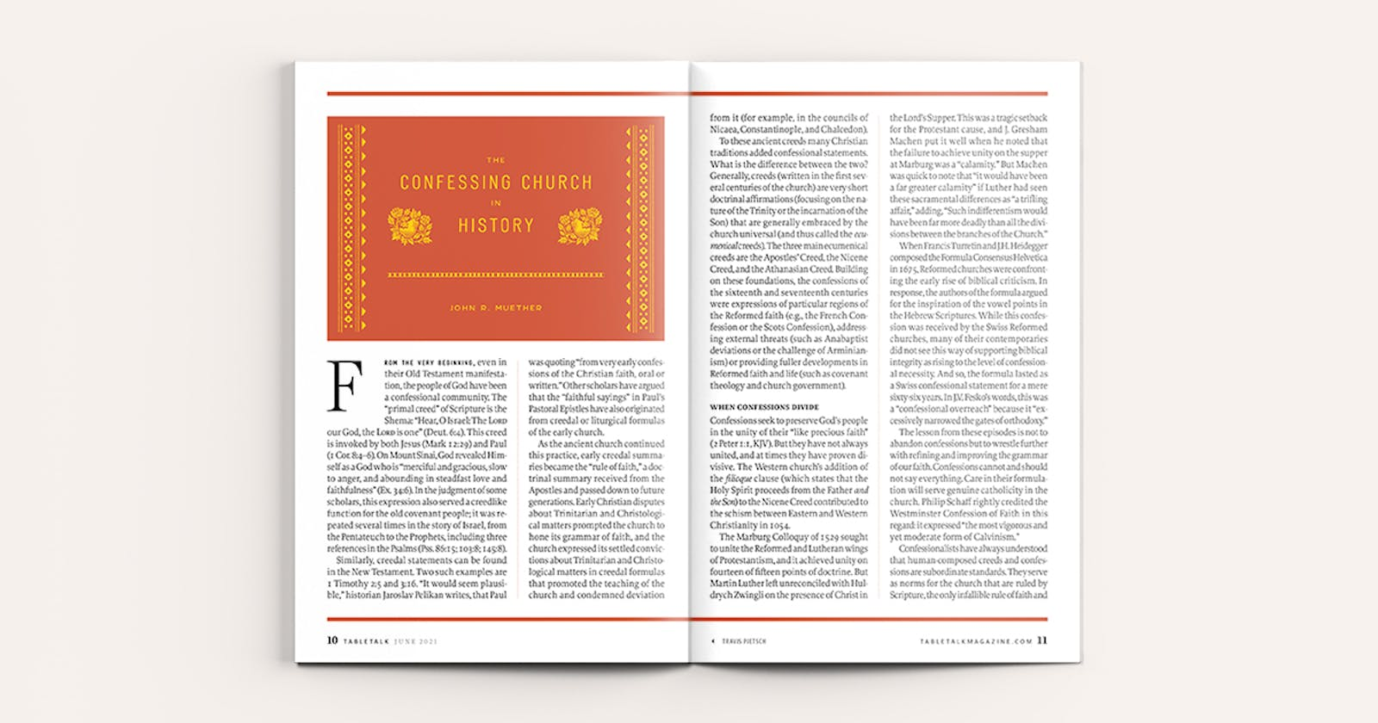
Discontent often arises from a thin notion of catholicity. If we minimize the confessions of our churches, wouldn’t a larger united church emerge? Wouldn’t a brief and generically evangelical statement of faith attract the greatest interest? Warfield argued that this approach was like “building a great house around a divided family.” The unity of the church never comes at the expense of its maturity in the faith. “We should consider well,” he adds, “whether this liberal pathway leads not in the end to tyranny.”

WHAT CONFESSIONS DO
These expressions of confessional disaffection underscore the widespread confusion in our day about the nature and purpose of church confessions. Again, Warfield is helpful here. He observed that confessions, rightly employed, provide three services to the church: they are tests, texts, and testimonies.
Confessions are tests when candidates are examined for church leadership. They form the basis of a church’s confidence of one’s fitness for office. This test binds the candidate’s faith—can he vow ex animo (from the heart) and will he commit himself to teach what the Bible reveals about, for example, the federal headship of Adam or the virgin birth of Christ?
Confessions are texts when they instruct the faithful in theology. Catechisms (confessional statements in question and answer form) are especially effective discipleship tools. Often based on the Apostles’ Creed, the Lord’s Prayer, and the Ten Commandments, they provide the means of training both the young and old in the Christian faith. Churches weaken their confessional identity when they neglect their duty to perfect the saints through catechesis.
Confessions are testimonies when they are the declarations of the faith of the church. This function includes the church’s corporate witness to a watching world and to other Christian churches, but it is especially seen when the church offers corporate praises and thanksgiving to God in its liturgical life. This entails the regular reading or reciting of portions of confessions in worship, but that is not all. The church’s confessions should shape the hymnody of the church. Public worship requires congregational song. When that is replaced by special music by professional performers, the church has robbed its flock of the privilege of confessing its faith. Moreover, the song of the church cannot be reduced to expressions of individual experience. The testimony of the church should not be “I Surrender” but rather “We Praise You Our God, Our Redeemer, Creator.” It is a hollow confession of faith whose theologically rich grammar does not shape the character of the church’s praise.
Tests, texts, and testimonies—these functions allow confessions to serve as the backbone for the confessing church, and they turn the argument about confessions and unity on its head. Far from undermining the cause of catholicity, confessions serve it. More often than not, Presbyterian splits have resulted from a departure from confessional fidelity. Without confessions, churches are tossed about by every wind of doctrine, disconnected from others by idiosyncratic interpretations and untethered from the Reformed tradition by fleeting concerns.

CONFESSIONS AS WIDE PLACES
In Psalm 18, David praises God for setting him in a broad place (v. 19) and a wide place (v. 36), language that is found elsewhere in the Old Testament. What is this broad place? Often associated with the promised land, it is a place of safety, freedom, and prosperity.
Confessional churches are often viewed as narrow places, where tightly held doctrines allow little deviation, leading some to fear a theological claustrophobia of tyrannical uniformitarianism. To be sure, confessions can be and have been misused. They can be reduced to hammers to enforce rigid uniformity in church courts.
But confessions in the history of the church reveal a different story. They can be a gift through which the church is called to maintain eager and cordial unity among its members and fellowship with the broader church. In Richard Muller’s words, a confession “provides boundaries for theological and religious expression, but it also offers considerable latitude for the development of varied theological and religious expression within those boundaries.” The greatest seasons of theological prosperity in the Reformed tradition have been characterized by heightened attention to its confessions. Far from being an impediment to the flourishing of the church, creeds and confessions are vital to the church’s unity, holiness, Apostolicity, and catholicity.

https://tabletalkmagazine.com/article/2021/06/the-confessing-church-in-history/

Nick Batzig尼古拉斯‧巴齊格牧師（@Nick_Batzig）是南卡羅來納州查理頓Church Creek 美洲長老教會的資深牧師，也是林格尼爾福音事工的副主編。他在Feeding on Christ上發表博客。

認信與敬拜 2022年08月31日
我兒時的回憶主要圍繞著和家人一起參加主日敬拜。我們所參與的改革宗長老教會的敬拜元素主要由解經式講道、讚美詩、禱告以及教會歷史上認信的信經和信條構成。我們常常宣讀使徒信經、尼西亞信經，或威斯敏斯特信仰告白、威斯敏斯特小要理問答和海德堡要理問答中一些特定的教義性的陳述。我們的牧師會在他們的講道中引述威斯敏斯特小要理問答的一些教義性陳述。儘管那時候的我尚未意識到這一點，但這些歷史性的教義準則確實從我年幼的時候起就開始在我心裡形塑聖經教義，敬拜規範和基督徒生活。十幾年前，我有幸建立了一間改革宗長老教會，我滿腔熱情地將許多歷史性的信條和認信納入崇拜儀式中，以此來實現保存基督教信仰的核心真理以及敬拜上帝的教導目標。

在闡明「那一次交付給聖徒」的信仰時，歷史性的教義準則幫助我們在正統信仰和錯誤的教導之間畫上鮮明的分割線。

巴刻在他1973年的文章「為了明日教會的認信」（Towards a Confession for Tomorrow’s Church）中堅稱，歷史性的信經和認信幫助教會履行四項原則性的責任：頌讚性（doxological）、說明性(declarative)、教導性（didactic）和紀律性（disciplinary）任務。據此，教會應當在敬拜中（頌讚性）、見證中（說明性）、教導中（教導性）和保護中（紀律性）充分利用歷史性的教義陳述。巴刻更進一步定義了信仰準則在每一項任務中如何具體地發揮其功用：
教會的頌讚性功用是藉著展現神愛的大工，並明文承諾盡當盡的責任作為回應，以此來榮耀神；教會的說明性功用是宣講信仰社群所信奉的內容，以此來顯明宣信的社群是屬基督的教會，是世界範圍內基督教信仰的共同體；教會的教導性功能指導會眾建立根基；教會的紀律性功用為每一位認信的基督徒劃定信仰界限建立根基，以多樣的教義性的限制或指導因應地影響教會內外的人。
其中頌讚性的責任範圍是最廣泛的，因為敬拜包含了說明性、教導性和紀律性責任。歷史性信經和信條旨在以宣講聖經的核心真理招聚信徒。信經與信條的教導性任務在於提供精煉的教義規範，以幫助牧師正確地教導和宣講聖經中上帝全備的旨意；信經與信條也有紀律性的指導作用，為教會領袖和會友提供教義性的標準，以便他們據此對彼此負責。信經與信條清晰的教義性定義像護欄一樣確保牧者在敬拜上帝這個背景之下進行宣講和教導，正如巴刻的解釋：
如果沒有經過授權的教義規範（長老會在歷史上對信經與信條的稱呼），那麼教會在保持其「真理的柱石和根基」（提前三15）這個特徵上明顯是沒有優勢的。當然，人所編寫的信仰準則固然是不完全的、也不具有最終的決定性，然而這些準則本身也是真實可信的，對於避免人誤入歧途、幫助每一代人盡可能清楚地知道基督教的真義來說是非常有用的。
當基督徒公開地認信教會歷來所相信的真理時，上帝就在分別教會與世界，也在分辨真教會與假教會。在闡明「那一次交付給聖徒」的信仰時，歷史性的教義準則幫助我們在正統信仰和錯誤的教導之間畫上鮮明的分割線。
最終，歷史性的教義規範藉著保持信徒的心專注於三一真神是信徒敬拜對象的這個核心真理，以此支持教會頌讚性的責任。信徒在三位一體論和基督論的陳述中彼此聯合。教會歷史上的信條和認信的鮮明特色是以神為中心、以基督為中心。此外，十七世紀改革宗的認信和要理問答詳細地解釋了根據聖經敬拜上帝的含義。威斯敏斯特信仰告白有一整章專門教導主日敬拜這個主題（二十一條），大要理問答在前四誡的解釋中詳細說明了合乎聖經的敬拜（大要理問答105，108-110，117）意味著什麼。
正確敬拜上帝根植於永不過時的聖經真理，因此教會應當熱切地支持並使用教會歷史上長久以來符合聖經真理的信仰規範。這樣有助於教會維護基督教真理和正確的敬拜上帝的方式，抵擋一切的歪曲和反對的作法。

https://zh.ligonier.org/tc/tabletalk/the-confessing-church/confessions-and-worship/

Confessions and Worship
Rev. Nicholas T. Batzig (@Nick_Batzig) is senior pastor of Church Creek PCA in Charleston, S.C., and an associate editor for Ligonier Ministries. He blogs at Feeding on Christ.

Some of my earliest childhood memories center on being with my family in worship on the Lord’s Day. In the Reformed and Presbyterian churches that we attended, expository preaching, hymn-singing, and prayer were fixed elements of worship, as were the historic creeds and confessions of the Christian church. We regularly confessed the Apostles’ Creed and the Nicene Creed—or some particular doctrinal statement out of the Westminster Confession of Faith, Westminster Shorter Catechism, or Heidelberg Catechism. Our pastors cited doctrinal statements from the Westminster Shorter Catechism in their sermons. Though I was unaware of it at the time, these historic doctrinal formulations were shaping my young mind in regard to biblical doctrine, worship, and the Christian life. Over a decade ago, I had the privilege of planting a Reformed and Presbyterian church. I enthusiastically incorporated many of the historic creeds and confessions into our worship service for the express purpose of instruction—as well as for the preservation of the core truths of the Christian faith and the worship of God.

Historic doctrinal standards help draw a sharp line between orthodox teaching and false teaching in the articulation of “the faith that was once for all delivered to the saints.”

In his 1973 article “Towards a Confession for Tomorrow’s Church,” J.I. Packer insisted that historic creeds and confessions assist the church in carrying out four principal responsibilities—its doxological, declarative, didactic, and disciplinary tasks. Accordingly, churches should make use of these historical doctrinal statements in their worship (doxological), witness (declarative), teaching (didactic), and conservation (disciplinary). Packer proceeded to define how they function in each task:

Their doxological function is to glorify God by setting forth his works of love and putting into words a responsive commitment. Their declarative function is to announce what the communities that espouse them stand for, and so to identify those communities as belonging to Christ’s church, the worldwide fellowship of faith. Their didactic function is to serve as a basis for instruction. Their disciplinary function is to establish the limits of belief within which each confessing body wishes to stay, and so to lay a foundation for whatever forms of doctrinal restriction or direction it may see fit to impose on its clerical and lay members.

The doxological task is the most extensive, since worship involves elements of the declarative, didactic, and disciplinary tasks. Historic creeds and confessions aid the gathered assembly of believers in declaring the core truths of Scripture. They serve the didactic assignment by offering ministers refined doctrinal formulations that assist them in rightly teaching and preaching the whole counsel of God from Scripture. They function as a disciplinary guide, giving leaders and members a doctrinal standard with which to hold one another accountable. Their clear doctrinal definitions act as guardrails to safeguard what is taught and proclaimed in the context of worship. As Packer explained:

Without authorized doctrinal formulae (standards, as Presbyterians have historically called them) the church is clearly at a disadvantage for maintaining its character as “the pillar and bulwark of the truth” (1 Tim. 3:15). Granted, no human formula of faith is complete or final; yet formularies can be true as far as they go, and very useful for excluding false trails and helping each generation to fulfil the task of making as clear as possible what Christianity really is.

When Christians publicly confess the truths that the church has always confessed, God is distinguishing between the church and the world—as well as between true and false churches. Historic doctrinal standards help draw a sharp line between orthodox teaching and false teaching in the articulation of “the faith that was once for all delivered to the saints” (Jude 3).
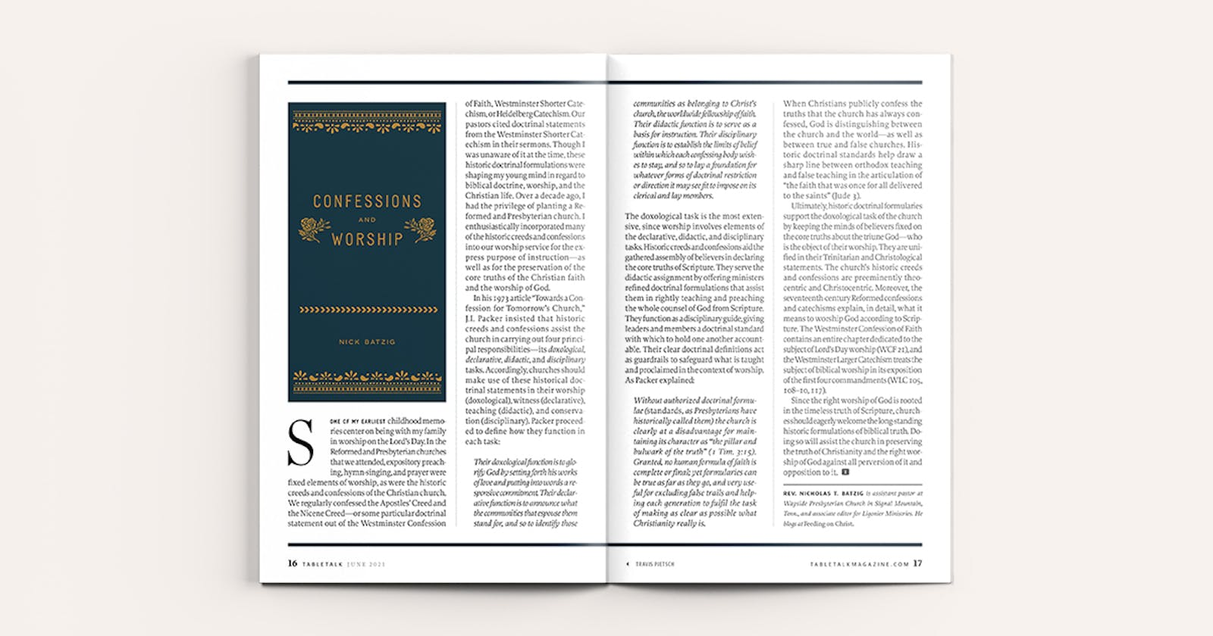

Ultimately, historic doctrinal formularies support the doxological task of the church by keeping the minds of believers fixed on the core truths about the triune God—who is the object of their worship. They are unified in their Trinitarian and Christological statements. The church’s historic creeds and confessions are preeminently theocentric and Christocentric. Moreover, the seventeenth-century Reformed confessions and catechisms explain, in detail, what it means to worship God according to Scripture. The Westminster Confession of Faith contains an entire chapter dedicated to the subject of Lord’s Day worship (WCF 21), and the Westminster Larger Catechism treats the subject of biblical worship in its exposition of the first four commandments (WLC 105, 108–10, 117).
Since the right worship of God is rooted in the timeless truth of Scripture, churches should eagerly welcome the long-standing historic formulations of biblical truth. Doing so will assist the church in preserving the truth of Christianity and the right worship of God against all perversion of it and opposition to it.

https://tabletalkmagazine.com/article/2021/06/confessions-and-worship/

David F. Coffin Jr. 牧師是位於維珍尼亞州費爾法克斯（Fairfax, Va.）的新希望長老教會的助理牧師，為教會提供聖經和神學教導。

認信與教會領袖 2022年09月02日
教義標準對於教會領袖忠心且有果效的事工有著很大的助力作用，這樣的標準以總結性、系統性的形式闡述重要的聖經教導，教義標準的形式經過了時間的考驗，被證明是典型的、忠於其來源的。當教會領袖們自願地接受這些教義標準時，它們就將那些將教會看作是「真理的柱石和根基」（提前三15）的教會聯合在了一起。
一般來說，教義標準對教會會友和教會領袖的作用是有所區分的。即使認信福音本質的會友在理解和遵守教義標準方面可能仍然存在著很大的差異。接納完整陳述的真理是門徒生命成熟的目標，而非前提。另一方面，教會要求領袖將教會的標準看作他們自己的標準，作為他們自己在神的話中找到的偉大真理的精準表達，這些標準可以指導他們的事工。這樣一來，真理就被交託給了「那忠心能教導別人的人」。（提後二2）
因此，教義標準大大降低了教會領袖候選人教義培訓的難度。教義標準為這樣的訓練提供了統一的課程，目標應該是要讓人覺得神學教導對他們來說更友善。而且能向會眾解釋這些教導並陳明其聖經根據也是同樣重要的。

教義標準是決定爭議結果的有力工具。

教義標準為候選人成為教會領袖做預備，也自然成為了查驗和認可領袖的至關重要的標準。為了在教義方面符合標準，所有的候選人必須能夠表明他們殷勤地學習並掌握了教會的教導，而且準備好要忠心地遵守這些教義標準來生活和牧養會眾。
不但如此，教義標準之於教會領袖的權柄和治理也非常重要。作為同樣被恩典地拯救的罪人，教會領袖的職分並沒有本質性的權柄。他們的權柄是道德性和屬靈性的。也就是說，他們的權柄基於忠誠地將真理呈現在神的百姓面前，藉著聖靈的工作， 教會領袖所照管的人就會接納和跟隨這些真理。這也就是教會領袖不可以訴諸武力權威的原因（和平民政府一樣）。相反，他們的治理是「牧養性和宣講性的」，是作為神話語的管理者透過以話語的指導來實施的。教會裡的治理總是通過教導真理實現的，教義標準為真理提供了可靠總結。基督「通過聖道和聖靈，透過服事的人間接地行使祂的主權和治理，推行祂自己的律法。」
最後需要的考慮一點是：教會領袖這個呼召不僅在於「能在正確的教義上給予指導」，而且還要預備 「責備違背教義的人（多一9）」。每個時代的教會領袖都必須注意保羅對以弗所長老發出的警告：「我知道在我離開之後，必有兇暴的豺狼進入你們中間，不顧惜羊群。 你們自己中間也必有人起來，講些歪曲悖謬的話，引誘門徒跟從他們。」（徒二十29-30）。因此，教會要求領袖要「為從前一次交付聖徒的真道竭力地爭辯」（猶3）。這一點更加重要，因為假教師會給教會帶來可怕的傷害，他們 「私自引進陷害人的異端」，真理的道路就被褻瀆（彼後二1）。
教義標準是決定爭議結果的有力工具。我們沒有必要在每次出現新的教導衝突時都從頭開始討論問題。問題的關鍵點永遠在於聖經是怎麼說的？關於這一點，教義標準表明了教會已經決定的結果，它們為這些爭議提供了框架和事先商定的要點，這樣，這些教義標準就適用於解決新出現的問題。通過這種方式可以維護教會的純潔與和平，因為教會領袖「保守所托付」給他們的（提前六20），並「牧養神的教會，就是基督用自己血所買來的教會」。（徒二十28）

https://zh.ligonier.org/tc/tabletalk/the-confessing-church/confessions-and-church-leadership/

Confessions and Church Leadership
Dr. David F. Coffin Jr. is assistant pastor for biblical and theological instruction at New Hope Presbyterian Church in Fairfax, Va.

Doctrinal standards are of great importance to the faithful and fruitful labor of church leaders. Such standards set forth some of the most important teachings of Scripture in a summary and systematic form, a form that typically has been tested over time and has proven faithful to its source. When voluntarily adopted by church leaders, they provide a bond of union for those joined together to care for the church as “a pillar and buttress of the truth” (1 Tim. 3:15).
Generally, confessional churches have distinguished between the function of a doctrinal standard with respect to church members and with respect to church leaders. Church members, having confessed the essentials of the gospel, may well be widely varied in their understanding of, and adherence to, the church’s doctrinal standards. A mature embrace of this fuller statement of the truth is a goal, not the prerequisite, for a life of discipleship. On the other hand, church leaders are required to embrace the church’s standards as their own, as an accurate statement of some of the great truths that they themselves find in the Word of God, and that will guide them in their labors. In this way, the truth is entrusted “to faithful men, who will be able to teach others also” (2 Tim. 2:2).
Thus, doctrinal standards are important in that they facilitate the doctrinal training of candidates for church leadership. They provide a uniform curriculum for such training, and the goal of this preparation should be a cordial embrace of their teaching. Also essential is the ability to explain that teaching to members and to show its foundation in the Bible.

Doctrinal standards provide a powerful tool in the calling to decide controversies.

Having provided for preparation, the doctrinal standards are essential in the examination and approval of church leaders. To qualify doctrinally, all candidates must be able to show that they have a conscientious grasp of the church’s teaching and a readiness to live and minister in faithful adherence to those standards.
Further, the doctrinal standards are of great importance to the authority and government of church leaders. As sinners saved by grace, such officers have no intrinsic authority. What authority they do have is moral and spiritual. That is to say, their authority depends on their faithfully setting before the people of God the truth, which by the work of the Spirit those under their care will embrace and follow. This is why the government of church leaders can have no appeal to force (as with civil governments). Rather, their government is “ministerial and declarative,” exercised through instruction, as administrators of the Word of God. Rule in the church is always a matter of instruction in the truth, and the doctrinal standards provide an approved summary of that truth. Christ exercises His authority and government in the church “through His Word and Spirit by the ministry of men; thus mediately exercising His own authority and enforcing His own laws.”
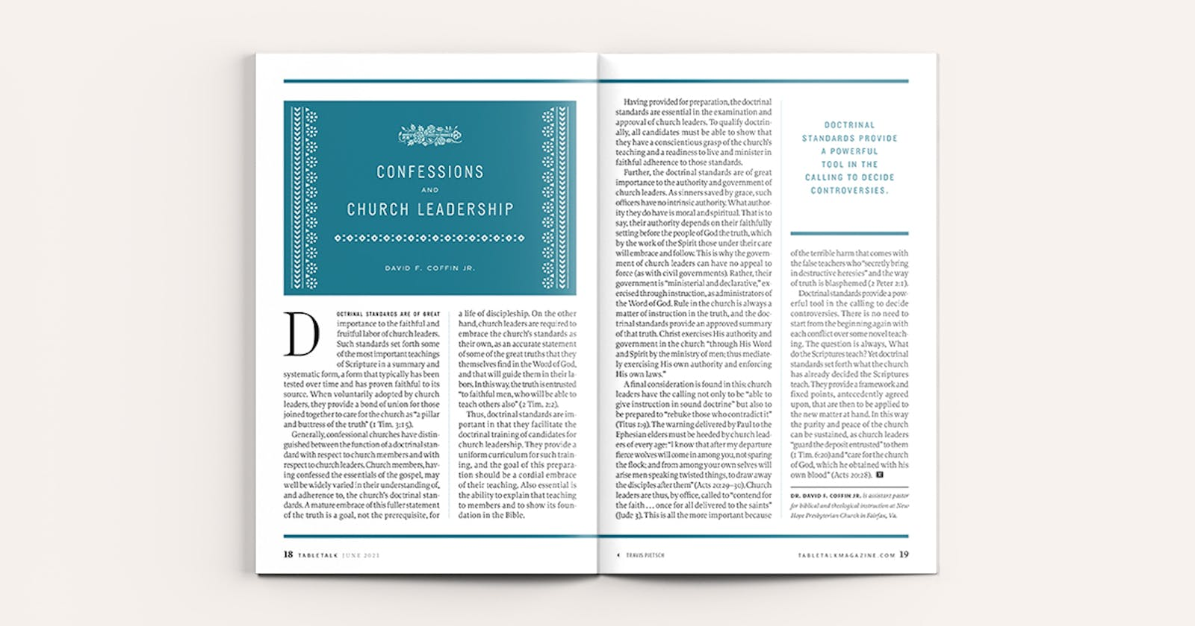

A final consideration is found in this: church leaders have the calling not only to be “able to give instruction in sound doctrine” but also to be prepared to “rebuke those who contradict it” (Titus 1:9). The warning delivered by Paul to the Ephesian elders must be heeded by church leaders of every age: “I know that after my departure fierce wolves will come in among you, not sparing the flock; and from among your own selves will arise men speaking twisted things, to draw away the disciples after them” (Acts 20:29–30). Church leaders are thus, by office, called to “contend for the faith once for all delivered to the saints” (Jude 3). This is all the more important because of the terrible harm that comes with the false teachers who “secretly bring in destructive heresies” and the way of truth is blasphemed (2 Peter 2:1).
Doctrinal standards provide a powerful tool in the calling to decide controversies. There is no need to start from the beginning again with each conflict over some novel teaching. The question is always, What do the Scriptures teach? Yet doctrinal standards set forth what the church has already decided the Scriptures teach. They provide a framework and fixed points, antecedently agreed upon, that are then to be applied to the new matter at hand. In this way the purity and peace of the church can be sustained, as church leaders “guard the deposit entrusted” to them (1 Tim. 6:20) and “care for the church of God, which he obtained with his own blood” (Acts 20:28).

https://tabletalkmagazine.com/article/2021/06/confessions-and-church-leadership/

Rev. Paul Levy is minister of International Presbyterian Church Ealing in West London.

信仰告白與教會會友 2022年09月07日
請跟我一起想像這樣一位牧師，他很有演講才能，他的教導清晰且鼓舞人心，同時他又是一位非常有天賦的領袖，他身上有著吸引別人跟隨的特質，也會被邀請在會議上發言。你已經認識了他和他的家人，開始確信他的教會正是你苦苦找尋的那一間。當你詢問這位牧師如何加入他的教會的時候，你卻開始覺得有點模糊。他談論很多關於教會的事，說會友彼此真誠以待，但當你進一步追問「這間教會相信什麼？」的時候，得到的卻是福音最基本的八個要點，以及「專注將重要的事放在首位，不把時間浪費在次要的事上」這樣的話。這話聽起來積極又正面，卻存在著一個隱憂：萬一哪裡出了錯怎麼辦？當會友的教會生活出現難題，甚至需要懲戒的時候又怎麼辦？教會是如何看待聖禮和信仰宣告的作用的？八點信仰摘要裡沒有提到的內容是不勝枚舉的。
根據宗教改革運動，教會懲戒是健康教會的標誌之一，然而這卻是當今教會最被忽視的方面之一。任何一位觀念正確的家長都會知道，教育孩子是不能不管教的，而今天大多數的福音派教會都忽視了這一點。對於教義宣言很少的教會來說有一個很大的難題，就是教會懲戒幾乎是不存在的，在這樣的教會中領袖常常不得不根據新的情況制定新的規則。可悲的是，這樣人們往往會因為不值得被懲戒的事遭到懲戒。儘管信仰教義八要點可能是正確的，然而對於處理會眾的日常生活來說是不夠具體的。

在這個混亂的時代，人們常常不知道自己信仰的是什麼，我們應該感恩並珍惜我們有信仰告白。

在一個教義宣言不多的教會裡，會友的屬靈生命健康與否基本上取決於領袖的屬靈生命。過去十幾年來，我們目睹了很多因為教會領袖跌倒、離開而導致整個教會分崩離析的悲劇。
更整全的信仰告白是為了尋求更好地理解聖經，以及更清晰地表達對神的話的理解。神在聖經中清楚地啓示了自己。當經文和經文比較的時候，本質性的教義就會越來越清晰，因此總結出來一致的聖經教導摘要是絕對可能的。
信仰告白為教會會友提供了好幾個益處：首先，信仰告白保證了我們的誠實。每一間教會都有自己的認信，問題是教會是否會將他們的認信寫下來。無論是西敏信仰告白，1689倫敦浸信會信仰宣言，或是三項聯合信條，信條清楚地表明一間教會的信仰是什麼，無處隱藏。教會領袖應當時常帶領會眾回顧信仰告白，好讓會友可以「從心裡順服了所傳給他們道理的模範」（羅六17）。我們應當尋求的是「那純正話語的規模」（提後一13）。
一個認信的教會應該要形塑會眾。歷史性的信條之美在於它們經受住了時間的考驗，讓人免受神學風潮或流動的領導人所帶來的負面影響。信仰告白呈現出一種成熟的神學反思，讓我們不被圍繞在我們周圍的神學錯誤所攪擾。
第二，信仰告白為教會會友提供了保護。信仰告白闡述了加入教會所必須的條件；它說明了什麼情況需要被懲戒、什麼情況則不需要；它提供了長老對人負責的標準；它為神學反思劃定界線；信仰告白成為了一種表達教牧關懷的方式；它為我們越來越成熟地理解神學指明了道路，因而使牧師和長老能夠牧養和鼓勵成員沿著門徒訓練的道路前進，同時也允許會友在誤入歧途時受到責備和勸告。
第三，持定信仰告白將我們和世界各地有類似想法的教會有意義地聯合起來，和歷史上有想法相似的教會也聯合起來。雖然改革宗的認信在表達自己的時候看起來各有不同，但是他們在所認信的恩典的主要教義方面是相同的。 第四，信仰告白為教會會友提供了在越來越敵視福音的文化中生活、思考和批判的工具。今天我們被挑戰的許多問題都需要以更整全、更深度的神學反思來回應。當我們查考這些總結聖經教導的改革宗信仰告白的時候，我們會發現自己正在被越來越多地裝備，為我們裏面的盼望提供緣由。

https://zh.ligonier.org/tc/tabletalk/the-confessing-church/confessions-and-church-membership/

Confessions and Church Membership
Imagine with me a preacher who’s a brilliant orator—his teaching is clear and inspirational, and he’s a gifted leader. There’s something about him that people want to follow. He has been invited to speak at conferences. You’ve gotten to know him and his family, and you’ve become convinced that his church is the one for you. You ask the pastor about how you join this church, but it’s a little bit fuzzy. There’s lots of talk about community and being real with one another, but when you ask, “What does this church believe?” you’re given an eight-point summary that contains only the bare necessities of the evangelical faith. “Keep the main things the main things,” he says to you, and “we don’t get hung up on the secondary matters in this place.” It all sounds so positive. But there’s a nagging worry: What about when things go wrong? What about when difficulties arise in church life and there’s a need for discipline? What does the church actually believe about the sacraments and the role of the state? There are so many issues not addressed by an eight-point summary.
One of the marks of the church, according to the Reformation, is church discipline, yet it’s one of the great neglected aspects of church life today. No one in their right mind would think they could bring up their children without any discipline, and yet the evangelical church today has in the main totally neglected this. The difficulty for a church with a minimal doctrinal statement is that if church discipline exists at all, leaders often have to make the rules up as they go. Sadly, people can end up being disciplined for things that do not merit discipline. Those eight points of doctrine, although they may be correct, are not detailed enough to deal with the issues that are faced in congregational life.

In a day that is confused, when people do not know what they believe, we should give thanks for and cherish our confessions of faith.

In a church with a minimalist statement of faith, the health of the congregation pretty much depends entirely on the spiritual health of the leader. In the last decade, we’ve seen tragic cases where leaders have fallen and the churches that they led have crumbled in the wake of their leaving.
A fuller confession of faith seeks to understand and express a clear understanding of the Word of God. God makes Himself clear in the Bible. As Scripture is compared with Scripture, the essential doctrine becomes clear, and so it is wonderfully possible to summarize the main points of biblical teaching coherently. We arrive in these confessions at what the Scriptures principally teach.
A confession of faith does a number of things for church members. First, it keeps us honest. Every church has a confession of faith, but the question is whether the church has written it down. Whether it’s the Westminster Confession of Faith, the 1689 London Baptist Confession, or the Three Forms of Unity, having a confession clearly sets out what the church believes, leaving no room to hide from it. Church leaders should regularly take their congregation through the confession so that they become “obedient from the heart to the standard of teaching to which you were committed” (Rom. 6:17). There is a “pattern of sound teaching” to which we should aspire (2 Tim. 1:13).
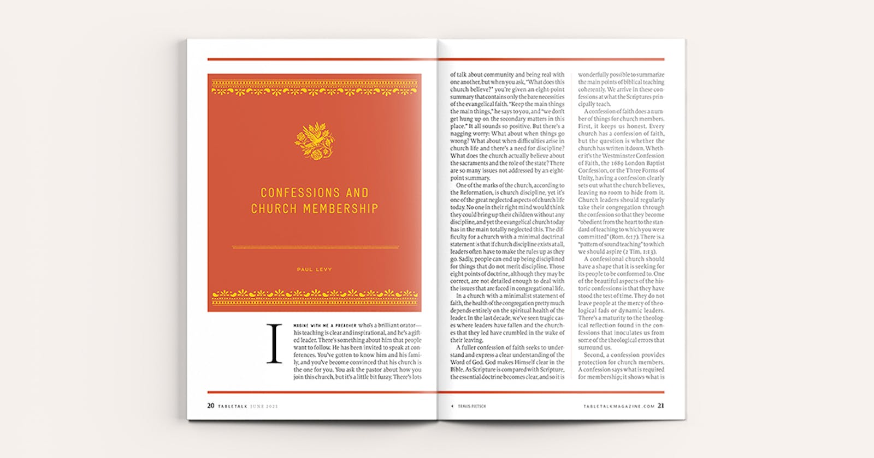

A confessional church should have a shape that it is seeking for its people to be conformed to. One of the beautiful aspects of the historic confessions is that they have stood the test of time. They do not leave people at the mercy of theological fads or dynamic leaders. There’s a maturity to the theological reflection found in the confessions that inoculates us from some of the theological errors that surround us.
Second, a confession provides protection for church members. A confession says what is required for membership; it shows what is and what isn’t a case for discipline; it gives criteria by which to hold elders accountable; it provides boundary markers for theological reflection. The confession becomes a method of expressing pastoral care. It shows us the path of theological maturity and so enables pastors and elders to shepherd and encourage members along that path of discipleship but also allows for rebuke and exhortation when those members go astray.
Third, holding a confession allows us to have meaningful unity with like-minded churches all over the world and down through history. Although the Reformed confessions might vary in the way they express themselves, the major doctrines of grace professed in them are the same.
Fourth, a confession of faith gives members tools to live in, think about, and critique a culture that is becoming increasingly hostile to the gospel. The questions that we are being asked today demand fuller, deeper theological reflection. As we go to these Reformed confessions that summarize the teaching of Scripture, we will find ourselves being equipped more and more to give a reason for the hope that is within us.

https://tabletalkmagazine.com/article/2021/06/confessions-and-church-membership/

Sebastian Heck塞巴斯蒂安-赫克是德國海德堡的 "獨立福音派"（Selbständige Evangelish-Reformierte Kirche）的組織者與牧師。

信仰告白與教會使命 2022年09月10日
當今社會，信仰告白的名聲莫名地不如人意。早期教會和宗教改革時期的教會為我們留下了久經考驗的信條以及信仰告白。在這些信條中，教會找到了「一次交付給聖徒的信仰」（猶大3）充滿權柄的總結。然而，今天有一種廣受歡迎的觀點，認為公開認信信仰告白的教會通常都沒有完成大使命的任務，人們認為信仰標準對於他們傳福音沒有幫助，反而是在積極地阻礙將清晰而簡單的福音信息帶給世界的努力。
可悲的是，這種看法是有一定道理的。認信的教會往往沒有像他們應該做的那樣熱心傳福音。更多的時候，他們關於各自認可的信條的辯論在外人看來更像是神學觀點的討論，是更細緻、更深奧的內部辯論。因此，許多人認為，宗教改革內涵豐富的認信標準本身就是對教會福音事工的一種阻礙。作為在後基督教時代的德國從事植堂工作的牧師，弟兄姊妹不止一次善意地提醒我不要把信仰告白當作傳福音、建立教會以及對初信信徒進行要理教導的工具。

以真理的話語向不信的世界宣信基督，這並不阻礙教會的宣教使命，反而是教會履行大使命的一部分。

認信信仰告白的教會確實常常缺乏傳福音的熱情，但是否能證明這一令人遺憾的事實可以歸咎於信仰告白？難道信仰告白在宣教處境中真的「沒有用」嗎？恰恰相反。雖然認信的教會在履行大使命方面可能確實是、而且經常是怠惰的，但問題並不在於信條本身。

信仰告白的真正目的
基督徒的真正呼召是背起自己的十字架，承認基督。這在當今世界許多地方的宣教處境中都是一樣的。在有些地方，承認相信基督甚至可能會對信徒的生命造成直接的威脅。但我們並不孤單，耶穌自己是第一個願意為祂的認信慷慨赴死的殉道者。祂的門徒當然不應該期望自己的境遇比他們的主人更好（約十三16）。基督要求門徒宣告他們對祂的認識，說出祂是誰（太十32；十六15），在付出代價之前要先計算代價並表明願意承受代價，這個代價甚至可能是死亡（十27-28）。信仰告白是我們對聖經的實際教導發自內心的信念，這種信念如此強烈，以至於我們寧可死也不願妥協真理。沒有人會願意為了他認為「很有可能 是真的」的事被燒死。然而，事實上有些基督徒已經因為他們認為是絕對真實的信仰告白被燒死在了火刑柱上，這真理是沒有任何例外或條件的。
翻閱那麼多教會信條的起源，我們會發現它們幾乎沒有一條是在舒適的環境中寫成的，而都是在迫害的烈火中由血寫成的。它們證明了殉道者的血實際上是教會的種子。舉一個例子就足以說明這一點。當圭多·德佈雷斯（Guido de Bres）在1561年撰寫《比利時信條》時，他還向西班牙統治者菲利普二世一併上交了一封信，在信中他闡述了他寫信仰告白背後的理由：

驅逐、監獄、枷鎖、流放、酷刑和其他數不清的迫害都清楚地表明，我們的渴慕和信念不是屬肉體的，因為如果我們不接受、不堅持這個教義，我們的生活會輕鬆得多。但我們敬畏神，對耶穌基督的警告也心存畏懼，祂說如果我們在人前否認祂，祂在神祂的父面前也會離棄我們，所以我們忍受背被鞭打，舌頭被割，嘴巴被堵，全身被燒是因為我們知道，願意跟隨基督的人必須捨己，背起他的十字架。

德佈雷斯和許多人都願意殉道，事實上他們也都因為他們的認信真的殉道了。因為他們知道，否認他們所相信的真理就是否認基督，而否認基督對人的靈魂有致命的損失，會奪走人得救唯一的希望。他們不惜付出死亡的代價也要宣告信仰，不為別的，只為了福音能傳開。每一位偉大而忠誠的宣教士願意，哪怕是勉強地願意竭力認信基督，都是出於真誠的心。
儘管教會的第一份信仰告白是為了陳述正統的信仰內容，也就是神學性地宣告真理，但它們從來都不是只為了教會而編定的，也是為了與屬世的錯誤信仰體系進行接觸。在教會認信中沒有死的正統這個觀念，信仰告白總是會挑戰我們，也會挑戰這個世界。
信仰告白的目的也是為了成為傳講福音的指南。並不是所有老舊的方式都是忠誠的，只有像這樣符合神話語真理的、由教會所認信的信仰告白摘要才是「宣講福音」忠誠的方式。信仰告白是真的「把話塞進我們的口中」，即符合聖經的話，使我們的信仰經歷有意義的話，以及我們在世界中見證基督時必須使用的話。信仰告白是歷經時間考驗的有效工具，用於全面地教授初信者和門徒基督教信仰的內容，就是基督教導我們的一切（太二十八20）。信仰告白為我們提供了話語，讓男女老少都能掌握信仰的內容。但在這些事中，編寫信仰告白的初衷是為了積極地宣告真正的信仰、真正的福音，以在基督裡的救恩裡將人奪回。

認信的行動
我們常常誤以為信仰告白是過時的東西，甚至是靜態不變的。我們將信仰告白放進「正統 」的文件夾，鎖進抽屜，有需要的時候才會拿出來，甚至可能永遠都不會再拿出來。但實際上，信仰告白是強有力的動態事件。它是發生在我們身上、發生在教會以及發生在世上的事。正如多蘿西·賽耶斯（Dorothy Sayers）所說，「教義就是一場戲」。堅定的、合乎聖經的信仰告白一再向我們再現上帝參與世界的這齣戲，通過祂的愛子也通過聖靈創世和救贖一個民族的一齣戲。我們所認信的讓我們立即地、完全地參與其中。當信徒個體張開嘴，宣告發自內心的信仰告白的時候，當教會全體張開嘴，宣告歷經考驗的信仰告白的時候，就是在由聖靈引導、以上帝真理的雙刃劍對抗有形以及無形的世界。這是神親自來審判和拯救失喪之人的事件。傳講福音和認信之間並不存在矛盾，前者是後者的功能和結果。信仰告白是可以想象的最反文化的行為。它向世界上不信的假設宣戰，否則就沒有什麼會質疑這些假設。

讓我們來認信吧
信仰告白是教會的傳聲筒。教會如果沒有宣告信仰，就成了啞巴，對於不信的世界就無話可說了。但當教會發聲時，神就會在祂的救贖工作中滿有能力地使用它們。那麼，為了選民的利益，讓我們堅守信仰告白。我們不要僅僅參與學院式的辯論，而是要真的擁有信仰告白，實現它本來的意圖：作蓋過魔鬼和世界謊言的擴音器；作真理的指南和堡壘；以及作使失喪者歸信的管道。
真正的認信是向外看的，它總是把我們引向屬靈的爭戰，甚至有可能讓我們殉道。然而，這正是使我們歸信、使教會成長的土壤。這可能是我在宣教領域學到的最重要的一課。
以真理的話語向不信的世界宣信基督，這並不阻礙教會的宣教使命，反而是教會履行大使命的一部分。

https://zh.ligonier.org/tc/tabletalk/the-confessing-church/confessions-and-the-mission-of-the-church/

Confessions and the Mission of the Church
Sebastian Heck is the organizing pastor of the Selbständige Evangelish-Reformierte Kirche in Heidelberg, Germany.

Confessions get a bad rap today. The ancient church and the churches of the Reformation bequeathed to us tried and tested creeds and confessions. In them, the church has found authoritative summaries of “the faith that was once for all delivered to the saints” (Jude 3). Today, however, there is a widespread and passionately held opinion that churches that outspokenly hold to a confession generally are not fulfilling the mandate of the Great Commission precisely because they are confessional. Their confessional standards, it is assumed, are not helping them evangelize. On the contrary, their standards are positively stymieing any true effort to bring a clear and simple gospel message to the world.
Sadly, there is some truth to that observation. Confessional churches are often not zealously evangelizing the world the way they should. More often than not, debates about their respective confessions look to the outsider as mere intramural debates about the finer, more esoteric points of theology. Thus, many think that the meaty confessional standards of the Reformation are in themselves a hindrance to the true missionary work of the church. As a minister engaged in the work of church planting in post-Christian Germany, I have more than once been told by well-meaning Christians not to use confessions as a tool to bring the gospel, to plant churches, and to catechize new converts.

To confess Christ with words of truth to an unbelieving world is not a hindrance to the missionary mandate of the church. Rather, it is part of how the church fulfills the Great Commission.

But does the deplorable fact that confessional churches often do lack evangelistic zeal prove that the problem lies with the confessions themselves? Do the confessions simply “not work” in a missionary context? Quite the contrary. While confessional churches may be, and often are, lax in fulfilling the Great Commission, the problem does not lie with the confessions themselves.

THE TRUE INTENTION OF CONFESSIONS
The true calling of the Christian is to take up his cross and to confess Christ. Frequently, in the missionary context in many regions of the world today, they are one and the same. Confessing Christ might and often does entail an immediate threat to the believer’s very life in many places. This puts us in good company. Jesus Himself was the first martyr to be willing to die on account of His confession. His disciples certainly should not expect to be above their Master (John 13:16). He required His disciples to confess who He was and is (Matt. 10:32; 16:15), counting the cost before they did so and being willing to suffer the consequences, possibly even death (10:27–28). A confession is our heartfelt conviction of what the Bible actually teaches, a conviction held so strongly that we would sooner die than compromise on the truth of it. No Christian has ever been willing to be burned at the stake for something he “quite possibly” holds to be true. But Christians have in fact died at the stake on account of a confession that they hold to be absolutely true—without exception or qualification.
We could go through the genesis of almost every single confession of the church and show that they were not written in cozy studies but forged in the fire of persecution and written in blood. They are evidence that the blood of martyrs is in fact the seed of the church. One example must suffice. When Guido de Bres penned the Belgic Confession in 1561, he also submitted a letter to the Spanish ruler Philip II in which he gave the rationale behind the confession. He wrote:

The banishments, prisons, racks, exiles, tortures, and countless other persecutions plainly demonstrate that our desire and conviction is not carnal, for we would lead a far easier life if we did not embrace and maintain this doctrine. But having the fear of God before our eyes, and being in dread of the warning of Jesus Christ, who tells us that he shall forsake us before God and his Father if we deny him before men, we suffer our backs to be beaten, our tongues to be cut, our mouths to be gagged and our whole body to be burnt, for we know that he who would follow Christ must take up his cross and deny himself.

De Bres and countless others were willing to be martyred, and were in fact martyred, on account of their confession. But why? Because they knew that to deny the truth of the confession is to deny Christ. And to deny Christ is deadly to the soul and takes away the only hope for people to be saved. They were willing to confess and die for no other reason than that the gospel would go forth. To be willing, even constrained, to confess Christ with intelligible words is the heart attitude behind every great and faithful missionary endeavor.
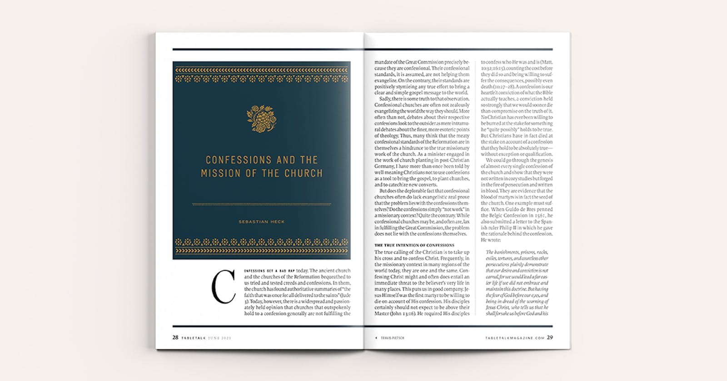

While the first confessions of the church were intended to be statements of orthodoxy—that is, of theological truth—they were never meant for the church alone but were always intended to be an engagement with the false belief systems of the world. There is no dead orthodoxy in the church’s confessions. They always challenge us, and they always challenge the world.
The confessions were also intended to be a guide for the preaching of the gospel. Not any old “gospel preaching” will do for the faithful evangelization of the world but only such that is in agreement with the truth of God’s Word as summarized in the church’s confessions. The confession literally puts words into our mouths—biblical words, words to make sense out of our experience of believing, and words that we can and must use as we go out into the world as witnesses for Christ. The confessions are time-tested tools for catechizing new converts and disciples into the full extent and content of the Christian faith, of all that Christ taught us (Matt. 28:20). They give us the words by which we, young and old alike, can own the content of the faith. But in all this, the most pristine intention of confessions has always been and always will be to be a positive declaration of the true faith and of the gospel in order to win people over to salvation in Christ.

THE ACT OF CONFESSING
We often misunderstand the confessions as something archaic, even static. We think of the confessions as documents to be filed under “orthodoxy” and kept in drawers until needed, if they ever are. But in truth, confessing the faith is a very powerful and dynamic event. It is something that happens—to us, to the church, and to the world. As Dorothy Sayers put it, “The dogma is the drama.” A solid, biblical confession recounts the drama of God’s involvement in the world to create and to redeem a people, the church, by His Son through the Spirit. What we confess immediately involves us completely, existentially. When the believer opens his mouth with a heartfelt confession, when the church collectively opens its mouth with a time-tested confession, it is a Spirit-led confrontation of the visible and invisible world with the two-edged sword of God’s truth. It is an event in which God Himself comes to judge and to save the lost. There is no contradiction between the preaching of the gospel and the confession of faith. The former is a function and consequence of the latter. Confessing the faith is the most countercultural act imaginable. It declares war on the unbelieving assumptions of the world that might otherwise go unchallenged.

LET US CONFESS
The confession is the megaphone of the church. When the church does not confess her faith, it becomes mute. It has nothing to say to the unbelieving world. But when it does, God uses it mightily in His work of salvation. For the sake of the elect, then, let us hold fast the confession of faith. Let us not engage in mere intramural debates but let us own the confession and use it the way it was always intended to be used: as a megaphone drowning out the lies of the devil and the world, as a guide to and bulwark of the truth, and as a means to convert the lost.
True confessionalism is always outward- looking. It always leads us right into spiritual warfare and quite possibly to martyrdom. That, however, is the soil in which conversions take place and the church grows. That may well be the most important lesson I have learned on the mission field.
To confess Christ with words of truth to an unbelieving world is not a hindrance to the missionary mandate of the church. Rather, it is part of how the church fulfills the Great Commission.

https://tabletalkmagazine.com/article/2021/06/confessions-and-the-mission-of-the-church/

未完

